India's Agriculture Crop Production Analysis 1997-2019



# PACHAIYAPPAS COLLEGE FOR MEN

# KANCHIPURAM- 631502

# TEAM MEMBERS:

# S.YOGESHWARAN

# V.VIKRAMAN

# E.VIMALRAJ

# K.SURYA

# V.VINITH KUMAR

# 

GUIDED BY:

DR.A.MANIGANDAN

# TEAM MEMBERS :



**Ind a s Agriculture Crop Product on Analysis**

* **Introduct on**
* **Problem Definit on and Design Think ng**
* **Advantages and Disadvantages**
* **Applica ons**
* **Future Scope**
* **Steps in tableau dashboard and story**
* **Conclusion**



**PROBLEM DEFINITION**

**The agricultural sector in Ind a plays a crucia role in the na on s economy livelihoods and food security flnderstand ng pa erns and trends in crop product on over the years 1997-2021 is vital for effect ve policy-making resource allocat on and sustainable agricultural practices. This project aims to**

**comprehensively ana yze Ind a s crop production da a spanning a period of 25 years to ident fy key pa erns factors influencing crop yields and potent a areas**

**for improvement**

# Empathy map

*WehavecreatedtheEmpathymapbybe****t****er understandingofproblem*

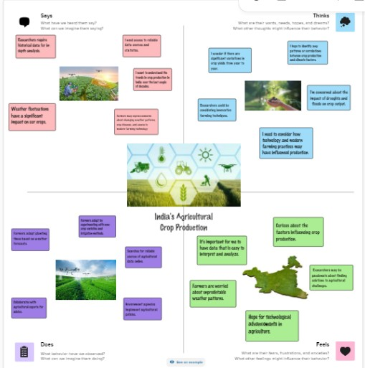

# Brainstorm and Idea Priorit zat on

As team we pointout the collect ideas as per person in the Brainstorm map

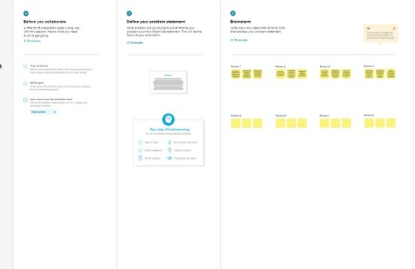

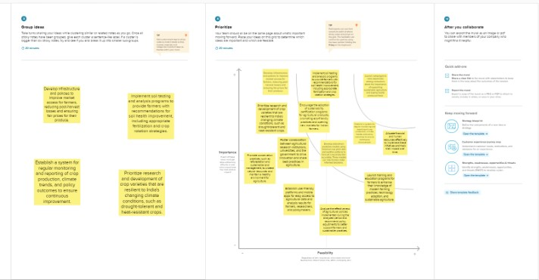

**Advantages and Disadvantages in Agr culture Crop product on analysis:**

Advantages:

Analyzing India s agricultural crop production data from 1997 to 2021 offers several significant advantages that contribute to informed decision-making policy formulation and sustainable agricultural practices. Here are the key advantages of conducting such an analysis:

## Policy Formulation and Implementat on

* + Insights derived from long-term crop production analysis can guide policymakers in formulating effective agricultural policies ensuring targeted support to specific crops regions or agricultural practices.

## Resource Allocation Optimization

* + flnderstanding crop production trends and patterns helps optimize resource allocation including water fertilizers and subsidies leading to enhanced efficiency and reduced wastage.

## Risk Mitigat on and Preparedness:

* + Historical analysis enables the identification of vulnerable regions or crops to environmental factors e.g. climate change extreme weather events . This aids in developing risk mitigation strategies and building resilience within the agricultural sector.

## Market Planning and Export Strategy

* + Analysis of crop production trends allows for better market planning and export strategies promoting efficient trade practices and identifying potential global markets for Indian agricultural products.

## Inf rmed Investment Decisions:

* + Investors both public and private can make informed decisions regarding investments in the agricultural sector based on historical data leading to sustainable growth and development.

## Technological and Innova on Adopt on:

* + flnderstanding past trends facilitates the identification of successful technologies and practices promoting their adoption to enhance crop yield quality and sustainability.

## Food Security and Supply Cha n Management

* + Accurate analysis aids in ensuring food security by identifying patterns in crop production that can influence the nation s food supply chain allowing for proactive measures to prevent food shortages.

## Sustainable Agriculture Promot on:

* + Historical data analysis supports the promotion of sustainable agricultural practices by identifying ecological impacts and suggesting measures to minimize environmental degradation.

## Knowledge and Skill Development

* + The analysis process itself contributes to the development of data analysis skills and knowledge within the agricultural research community and decision-makers fostering a data-driven approach.

## International Collaborat on and Cooperation:

* + Sharing comprehensive analysis results with international stakeholders fosters collaboration and cooperation in the agricultural domain leading to shared knowledge and best practices.

## Improved Crop Resilience and Variety Select on:

* + Insights into long-term crop performance aid in selecting more resilient crop varieties optimizing cultivation methods and promoting diversification to minimize risks and enhance overall agricultural productivity.



Disadvantages:

Analyzing India s Agriculture Crop Production 1997-2021 data presents several challenges and disadvantages that need to be considered to ensure a comprehensive and accurate assessment. Here are some notable disadvantages:

## Data Quality and Accuracy

* + Reliance on historical data raises concerns about the quality accuracy and consistency of data over a 25-year period. Inconsistencies errors and gaps in the data can affect the reliability of the analysis and subsequent conclusions.

## Incomplete or Missing Data

* + Data for certain years crops or regions may be incomplete or entirely missing making it challenging to establish a continuous and uniform dataset for analysis. Incomplete data can introduce bias and affect the overall findings.

## Changing C assif cation Systems:

* + Changes in classification systems agricultural practices or crop categorizations over the years can complicate comparisons and trend analysis. Reconciling data from different classification methods may introduce inaccuracies.

## Variable Data Availability

* + Data availability and reporting practices can vary across states and regions impacting the comparability and completeness of the dataset. Some regions might have more comprehensive data than others skewing the analysis.

## Seasonal Variations and Weather Impact

* + Agricultural production is highly influenced by seasonal variations and weather conditions. Variability in weather patterns over the years can significantly impact crop yields making it challenging to isolate the effects of other factors.

## Diverse Agroclimatic Regions:

* + India s diverse agroclimatic regions each with unique soil climate and growing conditions pose a challenge when attempting to generalize trends or recommendations across the entire country. Different regions may experience different challenges and outcomes.

## Complex Factors Inf uencing Production

* + Crop production is influenced by a multitude of factors such as technology adoption market dynamics government policies socio-economic conditions and global trends. Isolating the impact of each factor and understanding their interplay can be complex.

## Long-term Economic Changes:

* + Economic changes and market dynamics over 25 years including inflation trade policies and demand-supply fluctuations can significantly influence crop production trends making it difficult to attribute changes solely to agricultural practices.

## Limited Focus on Non-Ma or Crops:

* + The analysis might predominantly focus on major crops potentially overlooking the contributions and challenges of minor or underrepresented crops that are significant for certain regions or communities.

## Policy and Regula ory Changes:

* + Changes in agricultural policies subsidies and regulations over the years can impact crop production trends and may not be adequately captured in the analysis.

## Technological Advancement :

* + Rapid advancements in agricultural technology and practices might not be fully reflected in historical data affecting the analysis of productivity improvements.

**Applications**

India s Agriculture crop production analysis can be applied in policy-making resource allocation and technology adoption in the agricultural sector. By understanding historical trends and factors influencing crop yields from 1997 to 2021 policymakers can develop targeted policies to enhance productivity allocate resources efficiently and promote sustainable farming practices. Additionally agribusinesses can tailor marketing strategies identify export

opportunities and align production with market demands fostering growth and economic resilience in the agricultural industry.

**Future Scope**

The future scope of India s Agriculture crop production analysis lies in leveraging advanced technologies like artificial intelligence machine learning and big data analytics to gain deeper insights into agricultural patterns. By harnessing these tools we can enhance the accuracy and timeliness of crop yield predictions optimize resource allocation and recommend precision farming techniques. Moreover integrating weather data and climate modeling will enable us to better anticipate the impact of changing climate patterns on crops facilitating proactive adaptation strategies. This evolving approach will foster a data-driven sustainable agricultural landscape ensuring food security and prosperity for the nation.

Step-1. Step-2

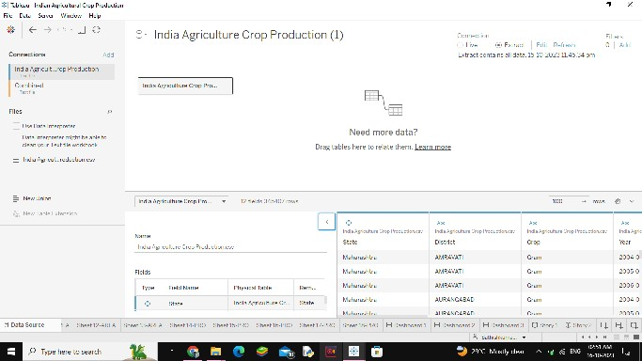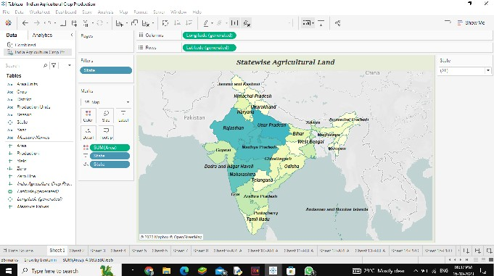

Step-3 Step-4

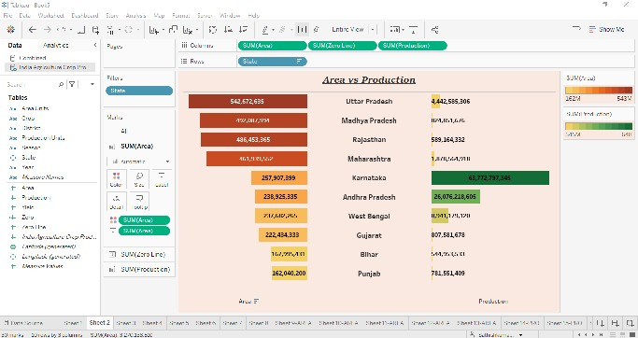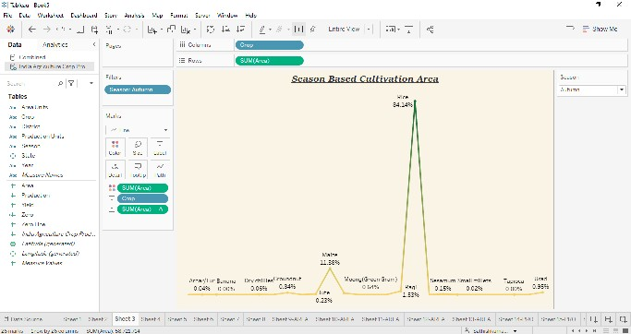

Step-5 Step-6

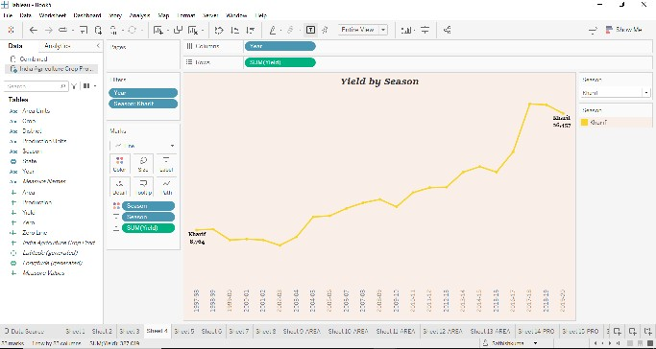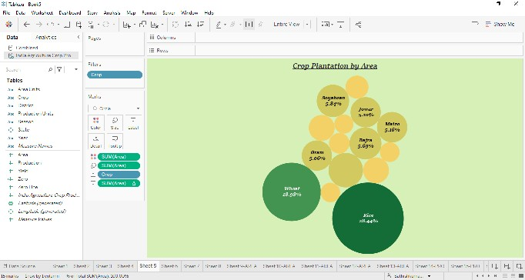

Step-7 Step-8

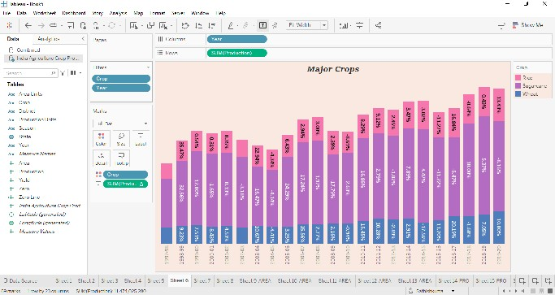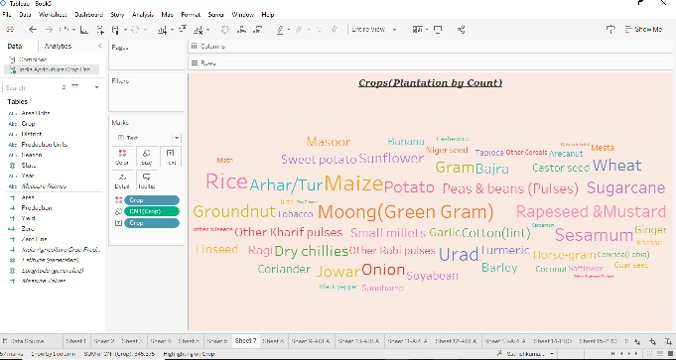

Step-9 Step-10

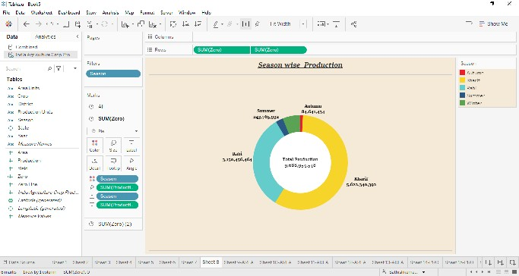.

Step-11 Step-12



Step-13 Step-14



Step-15 Step-16

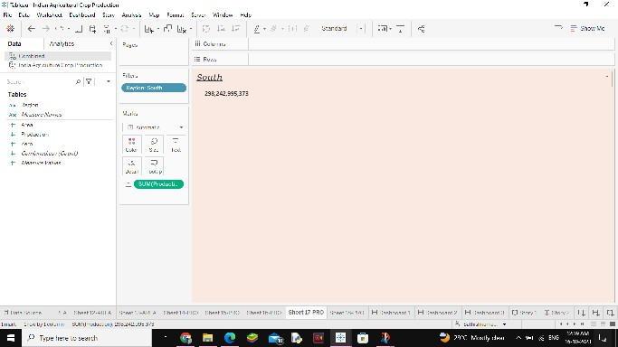

Step-17 Step-18



Step-19 Step-20

 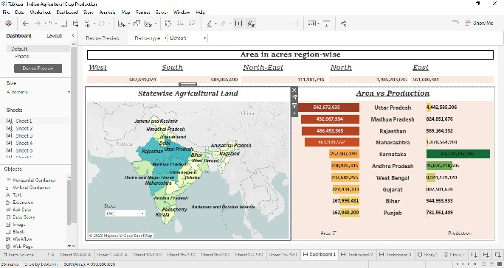

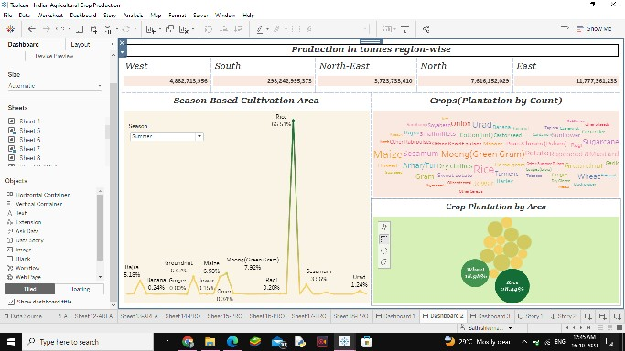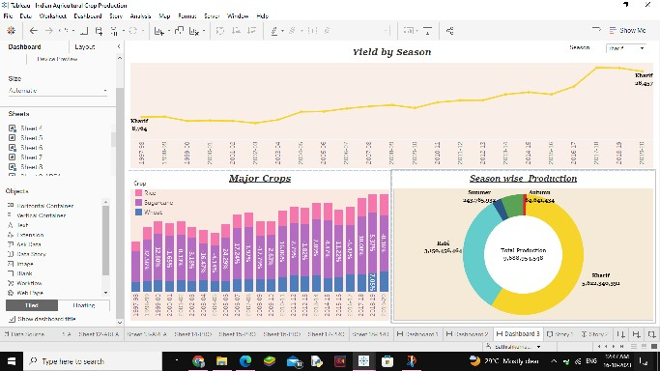Step-21 Step-22

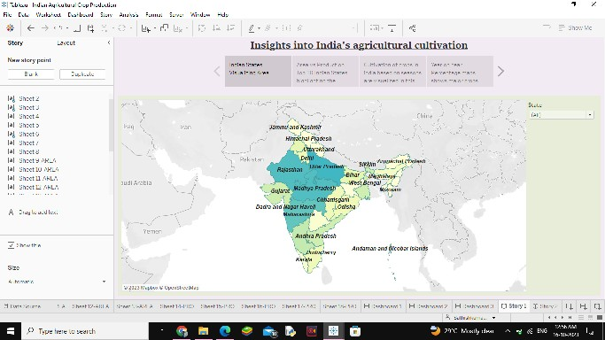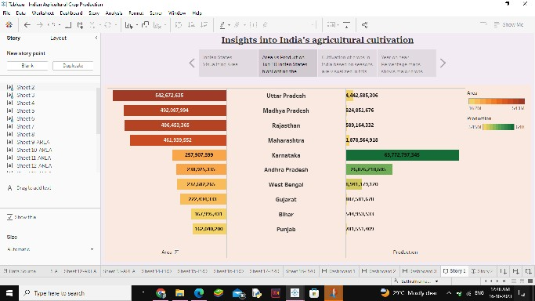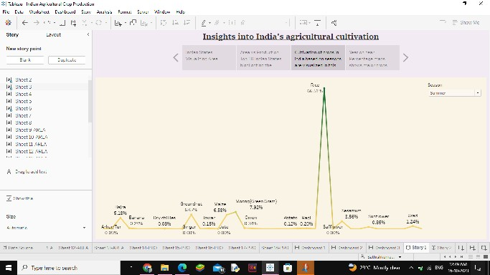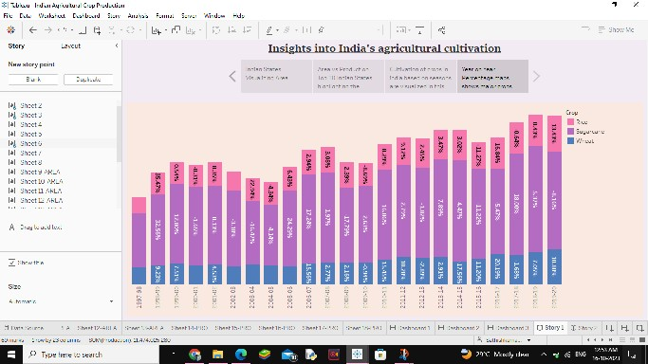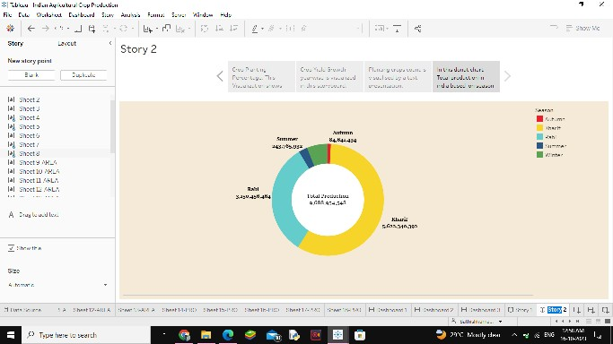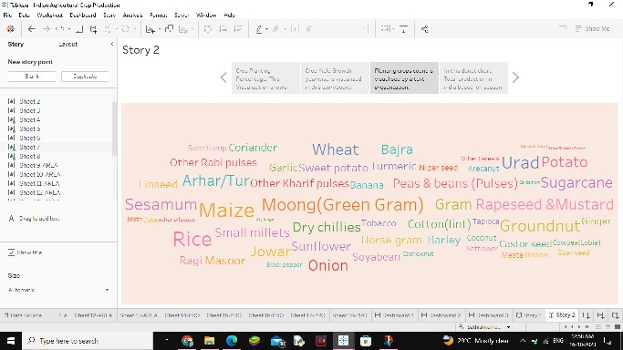Story:

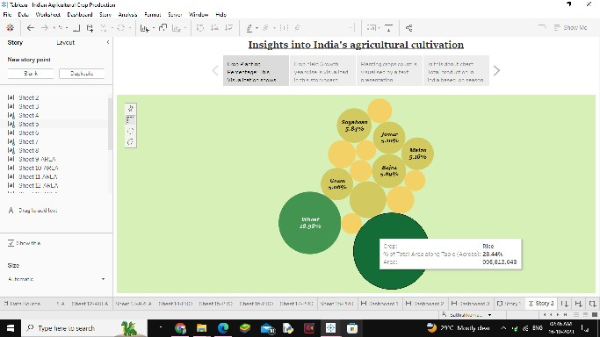

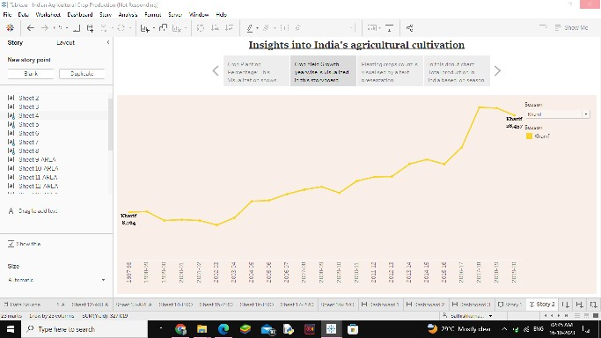.

**Conclusion**

In conclusion analyzing India s agricultural crop production data spanning 1997-2021 provides valuable insights for informed decision-making. This analysis helps identify trends challenges and opportunities within the agricultural sector. By leveraging these insights policymakers farmers and stakeholders can work collaboratively to enhance productivity optimize resource utilization and ensure sustainable agricultural growth. flltimately the aim is to foster a resilient and prosperous agricultural landscape that contributes to India s food security and economic development.